12th Interim meeting of the ASF Seafarers Committee
(Hong Kong, 15-17th January 2007)

COUNTRY REPORT
By

NACS

1 Current situation of local seafarers

The manpower age and employment issues seem almost the same as last year. For junior officer section, the number of students that graduated from METs is about 500 per year. There are four times national marine examinations were held and the ratio of student who succeeded in the national marine examination is about 12% now. The interesting change is the female new-blood deck mate joined the industry within the last three years and the number of person increased rapidly. Even the student who may pass the examination ratio average is 12%, but the ratio of the male is only 10.62% and the female is 22.45%. It’s supposed that shipboard traditional culture and heavy labor working requirement is not fit for eastern female, which may effect the willing of recruitment, therefore, only a small number of female can join the ship as deck officer and there is no female take the engineer position up to now.

For senior officer, it is about 30% whom can pass the upgrade assessment examination to join the industry, but the average age is older than before, particularly the management level engineer, its average age is more than 53 years now. Estimation by the industry, the number of officer and rating together with its age distribution please refer to the chart as attached. Although the average age of the seafarers in the area did not present any change on the surface, the junior female joined the industry that balanced the age should be aware of.

The market demands about 300 officers every year, including the junior, senior, deck, engine and shore base management staffs, however, the effective supply can only support about 200 seafarers. Since the shipping market in the area shows that the number of new deliver ship is more than the number to be scraped, therefore, the qualified seafarers short supply condition is foreseeable in the near future.
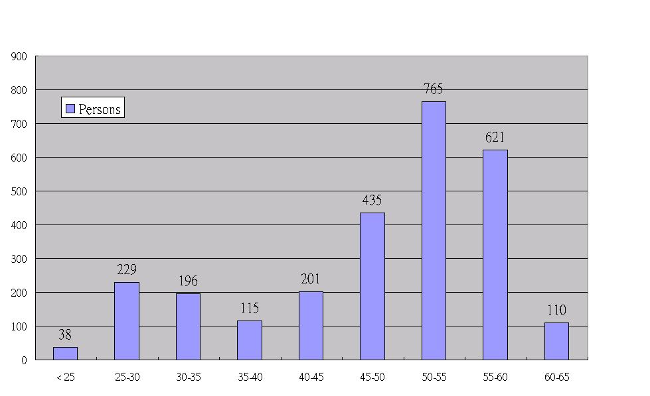
The statistics of seafarers’ age and number for the year of 2006

2. Recruitment and Training

In spite of the above-mentioned situation, we are glad to report that the issues of ship owner’s requirement of the seafarer have obtained government best attention and positive response now. Not only the country seafarer’s training, education and the examination systems will be modified by both Ministry of Transportation and Communications (MOTC) and Ministry of Examination within this (2007) year, but also her Ministry of Education will join to enhance the marine human resource quality by the education chain. Moreover, the national Ocean Education Policy White Book was revised at the end of 2006 and will be announced at the end of January 2007, trust the Ocean Education Policy will be the national ocean education guideline for the next 5-10 years.

The numbers of officers in the region are about 1,600 and 1,100 for ratings, There are about 1,350 officers and 930 ratings serviced on board now, this figure did not include the cadets, the for sea time on-board cadets are in surplus condition now.

To build the modern training ship is a hot topic for discussion between the industry and METs’ in the area, even though the case is still under Ministry of Education evaluation, the METs hope that ship can be built and be operated as early as possible.

Over the past five years, desiring to promote safety of life and the protection of the marine environment requirement highlights the importance of seafarers’ quality. Many ship owners, such as Evergreen and YML, have established her own crew MARPOL training; the contents of training lesson include the air pollution prevention and low sulfur oil exchange procedures.

For promotion the safety of life issue, some ship owner aware of the age problem and the importance of personal health management, have focused on the crewmember shipboard physical history items, working environment safety and weight the health conception education to her crewmembers now.

- End -

